**18CSC202J – OODP – C++ Lab 4 Exercises**

**Topic: Constructor & Destructor**

1. Write a program in C++ to convert a decimal number into binary without using an array and using the constructor and destructor.

## Sample Output

Please enter Decimal number: 8

binary number = 1000

1. Write a program in C++ to print Floyd’s Triangle by using the constructor destructor
2. Write C++ Program to display the cube of the number upto a given integer using Destructor.

**Sample Output**

Please enter the number:

4

cube of 1 is: 1

cube of 2 is: 8

cube of 3 is: 27

cube of 4 is: 64

1. Write a C++ Program to calculate Volume of Cube using constructor and destructor.
2. Write a program in C++ to make such a pattern like a pyramid with a number which will repeat the number in the same row using constructor overloading and destructor.
3. Write a C++ program to find the number and sum of all integer between 100 and 200 which are divisible by 9 with constructor destructor.
4. Write a C++ Program to display the reverse of a number using the constructor.
5. Write C++ program to demonstrate example of Parameterized Constructor

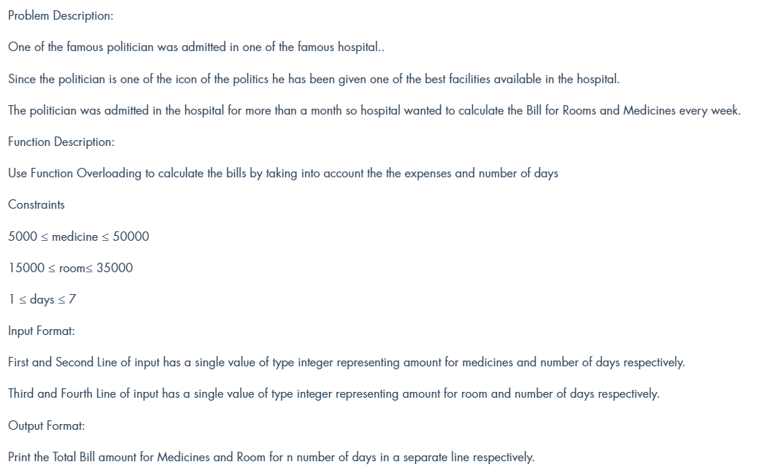

Sample output

Input: 5000  
 7

15000

7

Output: 35000

105000

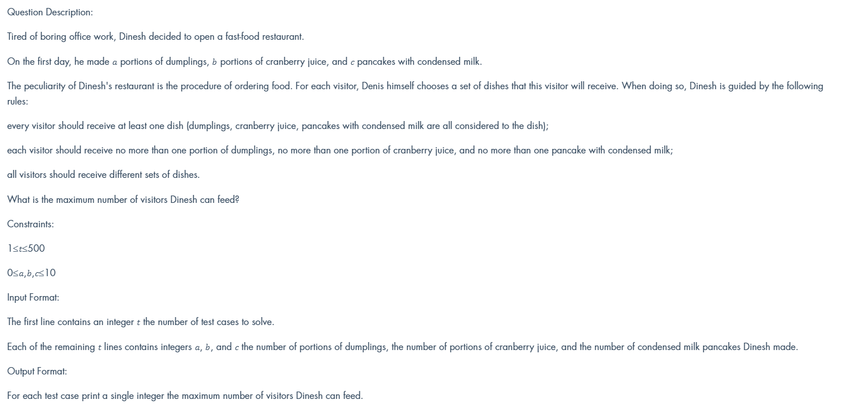

Sample output

Input: 2

2 2 8

3 2 2

Output: 20

40